32.41: a) At the sun’s surface:
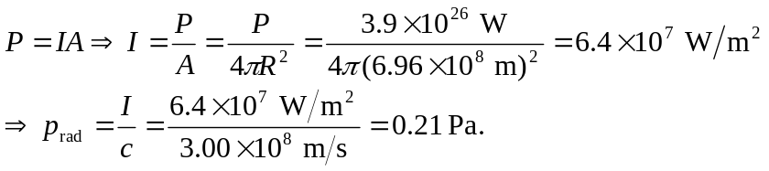
Halfway out from the sun’s center, the intensity is 4 times more intense, and so is the radiation pressure: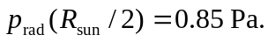
At the top of the earth’s atmosphere, the measured sunlight intensity is 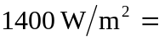
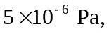 which is about 100,000 times less than the values above.
b) The gas pressure at the sun’s surface is 50,000 times greater than the radiation pressure, and halfway out of the sun the gas pressure is believed to be about 6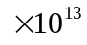 times greater than the radiation, pressure. Therefore it is reasonable to ignore radiation pressure when modeling the sun’s interior structure.

